

Topic test 1
Name: __________________________________

Chapter 2: Sets and basic probability

- Time allowed: 45 minutes
- CAS calculators may be used.
- Part A: 5 multiple-choice questions (5 marks)
- Part B: 7 short answer questions (31 marks)
- Part C: 2 analysis questions (14 marks)
Part A
5 multiple-choice questions
1 mark each: 5 marks
Circle the correct answer.
1 A  {n: n  3m  1, where m ∈ Z }, B  {n odd: 0 ≤ n ≤ 32}.
A ∩ B 
A {0, 1, 2, …, 29, 30, 31, 32, 34, 37, 40, 43, …}
B {0, 1, 2, …, 29, 30, 31, 32}
C {7, 11, 19, 25, 31}
D {4, 7, 10, 13, 16, 19, 22, 25, 28, 31}
E {7, 13, 19, 25, 31}

[1 mark]
2 A card is drawn from each of two normal packs of playing cards. Which sample space below represents the suits of the cards drawn? (Note that H  hearts, D  diamonds, C  clubs and S  spades.)
A {H, D, C, S, H, D, C, S}
B {HH, HD, HC, HS, DH, DD, DC, DS, CH, CD, CC, CS, SH, SD, SC, SS}
C {HD, HC, HS, DH, DC, DS, CH, CD, CS, SH, SD, SC}
D {HDCS, HDSC, HCDS, HCSD, DHCS, DHSC, DCHS, DCSH, CHDS, CHSD, CDHS, CDSH}
E {HDCS, HDSC, HCDS, HCSD, HSDC, HSCD, DHCS, DHSC, DCHS, DCSH, DSHC, DSCH, CHDS, CHSD, CDHS, CDSH, CSHD, CSDH, SHDC, SHCD, SDHC, SDCH, SCHD, SCDH}

[1 mark]
3 For the sample space for throwing two eight-sided dice numbered 1–8, n(total  12) 
A 1
B 8
C 6
D 5
E 4

[1 mark]
4 The probability that a card drawn from a normal pack is a club or an Ace is:
A 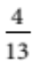
B 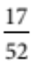
C
D 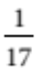
E

[1 mark]
5 In a class of 25 students, there are 4 who have no siblings, a set of twins who have another sibling, and
8 students who have one sibling. 7 more students have 2 siblings and the rest have more than 2 siblings.
Let A  ‘more than 2 siblings’ . P() 
A 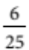
B 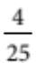
C 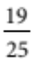
D 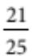
E

[1 mark]

Part B
7 short answer questions
31 marks
Show your working where appropriate.
1 Draw a Venn diagram to show the sets:
a (A ∩ B) ∪

b A ∩ (B ∪ )

[4 marks]
2 Write the following sample spaces.
a The sample space for selecting an Australian state or mainland territory.

b The sample space for choosing two different basic operations (from , ,  and ), with   and   being counted as different.

[5 marks]
3 What are the sample space and probabilities for finding the difference of two numbers, each chosen at random from 3, 4, 6 and 7?

[6 marks]

4 A decorations box contains coloured glass balls on strings. There are 4 green ones, 5 red ones and 2 blue ones. A coloured ball is taken out at random. Work out the probability for each colour.

[3 marks]
5 A box contains mixed nuts of comparable sizes, including 6 mm metric, 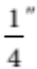 Whitworth, 6 mm fine metric
and 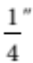 LH gas thread. To two decimal places, the probabilities of picking Whitworth, 6 mm metric
and LH gas thread nuts are 0.65, 0.25 and 0.03 respectively. The box actually contains 128 nuts. How
many are fine metric?

[5 marks]
6 From 90 washing machines checked by the quality control section in a factory, 7 were found to have faults. Estimate the probability of faulty machines and the number you would expect in a month’s production of
2500 machines.

[3 marks]
7 In a particular school, 40 Year 12 students are preparing folios to enter one of two local art colleges. 70% are applying to the first college and 10 are applying to both colleges. What is the probability that a student chosen at random is applying to the second college?

[5 marks]

Part C
2 analysis questions
14 marks
Show your working where appropriate.
1 A rectangle that measures 50 cm by 60 cm is divided 4 smaller rectangles as shown in the diagram.
Darts are thrown into the large rectangle to get one of the scores shown.
 |  | 40 cm
20 cm | 40 | 20
30 cm | 30 | 5
What are the sample space and probabilities for the scores?

[7 marks]
2 Prove that for mutually exclusive events A and B, n(A and (B or C))  n(A and C).

[7 marks]
Total marks: 50

Answers
Part A [1 mark each]
1 A  {4, 7, 10, 13, 16, 19, 22, 25, 28, 31, 34, …} and
B  {1, 3, 5, 7, 9, 11, 13, 15, 17, 19, 21, 23, 25, 27, 29, 31}
so A ∩ B  { 7, 13, 19, 25, 31}.
∴ E [1 mark]
2 For H first, the second can be H, D, C, S, and the same for each other suit, so
S  {HH, HD, HC, HS, DH, DD, DC, DS, CH, CD, CC, CS, SH, SD, SC, SS}.
∴ B [1 mark]
3 The event, ‘total  12’  {48, 57, 66, 75, 84}, so n(total  12)  5.
∴ D [1 mark]
4 n(club)  13, n(ace)  4 and n(ace of clubs)  1, so n(club or ace)  13  4  1  16.
Thus P(club or ace)  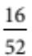  .
∴ A [1 mark]
5 n(0 siblings)  4, n(1 sibling)  8  2  10, n(2 siblings)  7, so n(more than 2 siblings)
 25 – (10  4  7)  4. Thus P()  .
∴ D [1 mark]
Part B
1 a 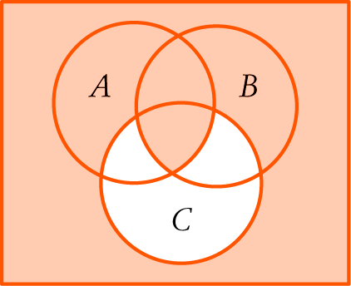 [2 marks]
b 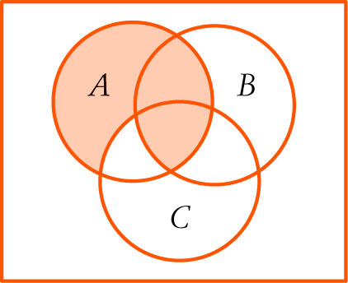 [2 marks]
[4 marks]
2 a {Vic., NSW, Qld, WA, Tas., NT, SA, ACT} [2 marks]
b { ,  ,  ,  ,  , 4,  ,  ,  4, 4 , 4 , 4 } [3 marks]
[5 marks]
3 S  {3  3, 3  4, 3  6, 3  7, 4  3, 4  4, 4  6, 4  7, 6  3, 6  4, 6  6, 6  7, 7  3,
7  4, 7  6, 7  7} [2 marks]
P(–4)  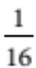, P(–3)  , P(–2)  , P(–1)  , P(0)  , P(1)  , P(2)  ,
P(3)  , P(4)  , [4 marks]
[6 marks]
4 P(green)  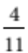, P(red) = 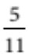, P(blue)  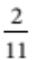 [1 mark each]
[3 marks]
5 P(fine metric)  1 – (0.65  0.25  0.03) [1 mark]
 0.07 [1 mark]
P(fine metric)  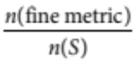, so 0.07  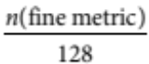 [1 mark]
so n(fine metric)  0.07  128 ≈ 9 [1 mark]
There are 9 fine metric nuts. [1 mark]
[5 marks]
6 P(faulty)  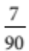 [1 mark]
Faulty from 2500  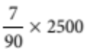 ≈ 194 [1 mark]
About 194 faulty machines will be expected. [1 mark]
[3 marks]
7 EITHER:
P(both colleges)  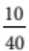  0.25 [1 mark]
P(either college)  P(first college)  P(second college)  P(both colleges) [1 mark]
1  0.7  P(second college)  0.25 [1 mark]
so P(second college)  0.55 [1 mark]
The probability that a student is applying for the second college is 0.55. [1 mark]
[5 marks]
OR
Number applying for first college  70% of 40  28 [1 mark]
Number applying for first college but not second  28  10  18 [1 mark]
Number applying for second college  40  18  22 [1 mark]
Probability of applying for second college  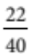  0.55 [2 marks]
[5 marks]
OR
Steps of the second method on a Venn diagram.
Part C
1 Assume that the probabilities are proportional to the areas and the darts land in the rectangle. [1 mark]
Area (40)  20  20  400 cm2
Area (30)  20  30  600 cm2
Area (20)  20  40  800 cm2
Area (5)  30  40  1200 cm2 [1 mark]
Total area  50  60  3000 cm2
Then S  {5, 20, 30, 40} [1 mark]
P(5)  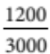  , P(20)  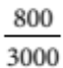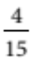, P(30)  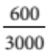 , P(40) 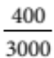  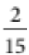 [1 mark each]
[7 marks]
2 Since A and B are mutually exclusive, n(A and B) = 0.
From P(A and B)  P(A)  P(B)  P(A or B), n(A and B)  n(A)  n(B)  n(A or B),
so n(A and (B or C))  n(A)  n(B or C)  n(A or (B or C)) [1 mark]
 n(A)  n(B or C)  n(A or B or C)
 n(A)  n(B or C)  n((A or B) or C) [1 mark]
Using n(A or B)  n(A)  n(B)  n(A and B),
n(A and (B or C))  n(A)  n(B or C)  n((A or B) or C)
 n(A)  n(B)  n(C)  n(B and C)  (n(A or B)  n(C)  n((A or B) and C))
[1 mark]
Because A and B are mutually exclusive,
n((A or B) and C)  n(A and C) 1 n(B and C) and n(A or B)  n(A) 1 n(B) [1 mark]
So n(A and (B or C))  n(A)  n(B)  n(C)  n(B and C)
(n(A)  n(B)  n(C)  n(A and C)  n(B and C)) [1 mark]
 n(A)  n(B)  n(C)  n(B and C)  n(A)  n(B)  n(C)
 n(A and C)  n(B and C) [1 mark]
 n(A and C) QED [1 mark]
[7 marks]

